[Acknowledgments](https://learning.oreilly.com/library/view/oracle-cloud-infrastructure/9781260452600/ack.xhtml" \l "ack" \t "_blank)

[Introduction](https://learning.oreilly.com/library/view/oracle-cloud-infrastructure/9781260452600/intro.xhtml#intro)

[Exam 1Z0-1072](https://learning.oreilly.com/library/view/oracle-cloud-infrastructure/9781260452600/exam.xhtml#exam)

[**Chapter 1**      Oracle Cloud Infrastructure Concepts](https://learning.oreilly.com/library/view/oracle-cloud-infrastructure/9781260452600/ch1.xhtml#ch1)

[Introduction to OCI](https://learning.oreilly.com/library/view/oracle-cloud-infrastructure/9781260452600/ch1.xhtml#lev1)

[**Exercise 1-1:** Create a New OCI Account](https://learning.oreilly.com/library/view/oracle-cloud-infrastructure/9781260452600/ch1.xhtml#lev1sec1)

[Cloud Computing Models](https://learning.oreilly.com/library/view/oracle-cloud-infrastructure/9781260452600/ch1.xhtml#lev2)

[OCI Features and Components](https://learning.oreilly.com/library/view/oracle-cloud-infrastructure/9781260452600/ch1.xhtml#lev3)

[Regions and Availability Domains](https://learning.oreilly.com/library/view/oracle-cloud-infrastructure/9781260452600/ch1.xhtml#lev1sec2)

[**Exercise 1-2:** Explore Your Availability Domain and Region](https://learning.oreilly.com/library/view/oracle-cloud-infrastructure/9781260452600/ch1.xhtml#lev1sec3)

[Off-Box Network Virtualization](https://learning.oreilly.com/library/view/oracle-cloud-infrastructure/9781260452600/ch1.xhtml#lev1sec4)

[OCI Concepts and Terms](https://learning.oreilly.com/library/view/oracle-cloud-infrastructure/9781260452600/ch1.xhtml#lev4)

[Identity and Access Management](https://learning.oreilly.com/library/view/oracle-cloud-infrastructure/9781260452600/ch1.xhtml#lev1sec5)

[Networking](https://learning.oreilly.com/library/view/oracle-cloud-infrastructure/9781260452600/ch1.xhtml#lev1sec6)

[Compute](https://learning.oreilly.com/library/view/oracle-cloud-infrastructure/9781260452600/ch1.xhtml#lev1sec7)

[Storage](https://learning.oreilly.com/library/view/oracle-cloud-infrastructure/9781260452600/ch1.xhtml#lev1sec8)

[Database Cloud Service](https://learning.oreilly.com/library/view/oracle-cloud-infrastructure/9781260452600/ch1.xhtml#lev1sec9)

[Chapter Review](https://learning.oreilly.com/library/view/oracle-cloud-infrastructure/9781260452600/ch1.xhtml#lev5)

[Questions](https://learning.oreilly.com/library/view/oracle-cloud-infrastructure/9781260452600/ch1.xhtml#lev1sec10)

[Answers](https://learning.oreilly.com/library/view/oracle-cloud-infrastructure/9781260452600/ch1.xhtml#lev1sec11)

[**Chapter 2**      OCI Identity and Access Management](https://learning.oreilly.com/library/view/oracle-cloud-infrastructure/9781260452600/ch2.xhtml#ch2)

[Explain IAM Concepts](https://learning.oreilly.com/library/view/oracle-cloud-infrastructure/9781260452600/ch2.xhtml#lev6)

[Resources](https://learning.oreilly.com/library/view/oracle-cloud-infrastructure/9781260452600/ch2.xhtml#lev1sec12)

[Tenancy and Compartments](https://learning.oreilly.com/library/view/oracle-cloud-infrastructure/9781260452600/ch2.xhtml#lev1sec13)

[Users](https://learning.oreilly.com/library/view/oracle-cloud-infrastructure/9781260452600/ch2.xhtml#lev1sec14)

[Groups](https://learning.oreilly.com/library/view/oracle-cloud-infrastructure/9781260452600/ch2.xhtml#lev1sec15)

[Policies](https://learning.oreilly.com/library/view/oracle-cloud-infrastructure/9781260452600/ch2.xhtml#lev1sec16)

[Dynamic Groups](https://learning.oreilly.com/library/view/oracle-cloud-infrastructure/9781260452600/ch2.xhtml#lev1sec17)

[Describe Resource Locations and Identifiers](https://learning.oreilly.com/library/view/oracle-cloud-infrastructure/9781260452600/ch2.xhtml#lev7)

[Resource Locations](https://learning.oreilly.com/library/view/oracle-cloud-infrastructure/9781260452600/ch2.xhtml#lev1sec18)

[**Exercise 2-1:** Subscribe to Another Region](https://learning.oreilly.com/library/view/oracle-cloud-infrastructure/9781260452600/ch2.xhtml#lev1sec19)

[**Exercise 2-2:** Create a Compartment and a VCN](https://learning.oreilly.com/library/view/oracle-cloud-infrastructure/9781260452600/ch2.xhtml#lev1sec20)

[Resource Identifiers](https://learning.oreilly.com/library/view/oracle-cloud-infrastructure/9781260452600/ch2.xhtml#lev1sec21)

[Managing Tags and Tag Namespaces](https://learning.oreilly.com/library/view/oracle-cloud-infrastructure/9781260452600/ch2.xhtml#lev1sec22)

[Advanced Policies](https://learning.oreilly.com/library/view/oracle-cloud-infrastructure/9781260452600/ch2.xhtml#lev1sec23)

[Create IAM Resources](https://learning.oreilly.com/library/view/oracle-cloud-infrastructure/9781260452600/ch2.xhtml#lev8)

[Create Compartments](https://learning.oreilly.com/library/view/oracle-cloud-infrastructure/9781260452600/ch2.xhtml#lev1sec24)

[**Exercise 2-3:** Create Compartments for Organization](https://learning.oreilly.com/library/view/oracle-cloud-infrastructure/9781260452600/ch2.xhtml#lev1sec25)

[Create Groups, Users, Policies](https://learning.oreilly.com/library/view/oracle-cloud-infrastructure/9781260452600/ch2.xhtml#lev1sec26)

[**Exercise 2-4:** Create Groups, Users, and Policies](https://learning.oreilly.com/library/view/oracle-cloud-infrastructure/9781260452600/ch2.xhtml#lev1sec27)

[Federate OCI with Various Identity Providers](https://learning.oreilly.com/library/view/oracle-cloud-infrastructure/9781260452600/ch2.xhtml#lev9)

[Set Up Dynamic Groups](https://learning.oreilly.com/library/view/oracle-cloud-infrastructure/9781260452600/ch2.xhtml#lev10)

[Chapter Review](https://learning.oreilly.com/library/view/oracle-cloud-infrastructure/9781260452600/ch2.xhtml#lev11)

[Questions](https://learning.oreilly.com/library/view/oracle-cloud-infrastructure/9781260452600/ch2.xhtml#lev1sec28)

[Answers](https://learning.oreilly.com/library/view/oracle-cloud-infrastructure/9781260452600/ch2.xhtml#lev1sec29)

[**Chapter 3**      OCI Networking](https://learning.oreilly.com/library/view/oracle-cloud-infrastructure/9781260452600/ch3.xhtml#ch3)

[Networking Concepts and Terminology](https://learning.oreilly.com/library/view/oracle-cloud-infrastructure/9781260452600/ch3.xhtml#lev12)

[CIDR](https://learning.oreilly.com/library/view/oracle-cloud-infrastructure/9781260452600/ch3.xhtml#lev1sec30)

[**Exercise 3-1:** Expand CIDR Notation](https://learning.oreilly.com/library/view/oracle-cloud-infrastructure/9781260452600/ch3.xhtml#lev1sec31)

[Virtual Cloud Networks](https://learning.oreilly.com/library/view/oracle-cloud-infrastructure/9781260452600/ch3.xhtml#lev1sec32)

[Subnets](https://learning.oreilly.com/library/view/oracle-cloud-infrastructure/9781260452600/ch3.xhtml#lev1sec33)

[Gateways](https://learning.oreilly.com/library/view/oracle-cloud-infrastructure/9781260452600/ch3.xhtml#lev1sec34)

[Use Virtual Cloud Networks](https://learning.oreilly.com/library/view/oracle-cloud-infrastructure/9781260452600/ch3.xhtml#lev13)

[**Exercise 3-2:** Create VCNs and Subnets](https://learning.oreilly.com/library/view/oracle-cloud-infrastructure/9781260452600/ch3.xhtml#lev1sec35)

[**Exercise 3-3:** Deploy a NAT Gateway](https://learning.oreilly.com/library/view/oracle-cloud-infrastructure/9781260452600/ch3.xhtml#lev1sec36)

[**Exercise 3-4:** Deploy a Service Gateway](https://learning.oreilly.com/library/view/oracle-cloud-infrastructure/9781260452600/ch3.xhtml#lev1sec37)

[**Exercise 3-5:** Set Up Local VCN Peering](https://learning.oreilly.com/library/view/oracle-cloud-infrastructure/9781260452600/ch3.xhtml#lev1sec38)

[**Exercise 3-6:** Set Up Remote VCN Peering](https://learning.oreilly.com/library/view/oracle-cloud-infrastructure/9781260452600/ch3.xhtml#lev1sec39)

[DNS in OCI](https://learning.oreilly.com/library/view/oracle-cloud-infrastructure/9781260452600/ch3.xhtml#lev14)

[DNS Concepts and Features](https://learning.oreilly.com/library/view/oracle-cloud-infrastructure/9781260452600/ch3.xhtml#lev1sec40)

[Creating and Managing DNS Records](https://learning.oreilly.com/library/view/oracle-cloud-infrastructure/9781260452600/ch3.xhtml#lev1sec41)

[**Exercise 3-7:** Set Up a DNS Zone and Resource Records](https://learning.oreilly.com/library/view/oracle-cloud-infrastructure/9781260452600/ch3.xhtml#lev1sec42)

[Load Balancers in OCI](https://learning.oreilly.com/library/view/oracle-cloud-infrastructure/9781260452600/ch3.xhtml#lev15)

[Load Balancer Terminology and Concepts](https://learning.oreilly.com/library/view/oracle-cloud-infrastructure/9781260452600/ch3.xhtml#lev1sec43)

[**Exercise 3-8:** Set Up a Load Balancer](https://learning.oreilly.com/library/view/oracle-cloud-infrastructure/9781260452600/ch3.xhtml#lev1sec44)

[Design and Secure OCI Networks](https://learning.oreilly.com/library/view/oracle-cloud-infrastructure/9781260452600/ch3.xhtml#lev16)

[VCN Design](https://learning.oreilly.com/library/view/oracle-cloud-infrastructure/9781260452600/ch3.xhtml#lev1sec45)

[Edge Security](https://learning.oreilly.com/library/view/oracle-cloud-infrastructure/9781260452600/ch3.xhtml#lev1sec46)

[Chapter Review](https://learning.oreilly.com/library/view/oracle-cloud-infrastructure/9781260452600/ch3.xhtml#lev17)

[Questions](https://learning.oreilly.com/library/view/oracle-cloud-infrastructure/9781260452600/ch3.xhtml#lev1sec47)

[Answers](https://learning.oreilly.com/library/view/oracle-cloud-infrastructure/9781260452600/ch3.xhtml#lev1sec48)

[**Chapter 4**      Compute Instances](https://learning.oreilly.com/library/view/oracle-cloud-infrastructure/9781260452600/ch4.xhtml#ch4)

[Compute Service Components](https://learning.oreilly.com/library/view/oracle-cloud-infrastructure/9781260452600/ch4.xhtml#lev18)

[Compute Shapes](https://learning.oreilly.com/library/view/oracle-cloud-infrastructure/9781260452600/ch4.xhtml#lev1sec49)

[Compute Images](https://learning.oreilly.com/library/view/oracle-cloud-infrastructure/9781260452600/ch4.xhtml#lev1sec50)

[Instance Management](https://learning.oreilly.com/library/view/oracle-cloud-infrastructure/9781260452600/ch4.xhtml#lev19)

[Create Compute Instances](https://learning.oreilly.com/library/view/oracle-cloud-infrastructure/9781260452600/ch4.xhtml#lev1sec51)

[**Exercise 4-1:** Create an SSH Key Pair](https://learning.oreilly.com/library/view/oracle-cloud-infrastructure/9781260452600/ch4.xhtml#lev1sec52)

[**Exercise 4-2:** Create a Compute Instance to Use as a Web Server](https://learning.oreilly.com/library/view/oracle-cloud-infrastructure/9781260452600/ch4.xhtml#lev1sec53)

[**Exercise 4-3:** Create and Use a Custom Image](https://learning.oreilly.com/library/view/oracle-cloud-infrastructure/9781260452600/ch4.xhtml#lev1sec54)

[**Exercise 4-4:** Create a Load Balancer to Route Traffic to Web Servers](https://learning.oreilly.com/library/view/oracle-cloud-infrastructure/9781260452600/ch4.xhtml#lev1sec55)

[**Exercise 4-5:** Create and Connect to a Windows Compute Instance](https://learning.oreilly.com/library/view/oracle-cloud-infrastructure/9781260452600/ch4.xhtml#lev1sec56)

[Manage Compute Instances](https://learning.oreilly.com/library/view/oracle-cloud-infrastructure/9781260452600/ch4.xhtml#lev1sec57)

[Instance Configurations, Pools, and Autoscaling](https://learning.oreilly.com/library/view/oracle-cloud-infrastructure/9781260452600/ch4.xhtml#lev1sec58)

[Instance Console Connections](https://learning.oreilly.com/library/view/oracle-cloud-infrastructure/9781260452600/ch4.xhtml#lev1sec59)

[Chapter Review](https://learning.oreilly.com/library/view/oracle-cloud-infrastructure/9781260452600/ch4.xhtml#lev20)

[Questions](https://learning.oreilly.com/library/view/oracle-cloud-infrastructure/9781260452600/ch4.xhtml#lev1sec60)

[Answers](https://learning.oreilly.com/library/view/oracle-cloud-infrastructure/9781260452600/ch4.xhtml#lev1sec61)

[**Chapter 5**      Storage](https://learning.oreilly.com/library/view/oracle-cloud-infrastructure/9781260452600/ch5.xhtml#ch5)

[Block Storage](https://learning.oreilly.com/library/view/oracle-cloud-infrastructure/9781260452600/ch5.xhtml#lev21)

[Create Block Volumes](https://learning.oreilly.com/library/view/oracle-cloud-infrastructure/9781260452600/ch5.xhtml#lev1sec62)

[**Exercise 5-1:** Create a Block Volume](https://learning.oreilly.com/library/view/oracle-cloud-infrastructure/9781260452600/ch5.xhtml#lev1sec63)

[Attaching Block Volumes](https://learning.oreilly.com/library/view/oracle-cloud-infrastructure/9781260452600/ch5.xhtml#lev1sec64)

[**Exercise 5-2:** Attach a Block Volume to a Linux Instance](https://learning.oreilly.com/library/view/oracle-cloud-infrastructure/9781260452600/ch5.xhtml#lev1sec65)

[Connecting Block Volumes](https://learning.oreilly.com/library/view/oracle-cloud-infrastructure/9781260452600/ch5.xhtml#lev1sec66)

[**Exercise 5-3:** Connect a Block Volume to Your Linux Volume Using iSCSI and CHAP](https://learning.oreilly.com/library/view/oracle-cloud-infrastructure/9781260452600/ch5.xhtml#lev1sec67)

[**Exercise 5-4:** Format a Block Volume, Create a File System, and Mount the Volume](https://learning.oreilly.com/library/view/oracle-cloud-infrastructure/9781260452600/ch5.xhtml#lev1sec68)

[**Exercise 5-5:** Present a Block Volume to a Windows Instance](https://learning.oreilly.com/library/view/oracle-cloud-infrastructure/9781260452600/ch5.xhtml#lev1sec69)

[Block Volume Backup Options](https://learning.oreilly.com/library/view/oracle-cloud-infrastructure/9781260452600/ch5.xhtml#lev1sec70)

[**Exercise 5-6:** Create a Full Backup of a Block Volume](https://learning.oreilly.com/library/view/oracle-cloud-infrastructure/9781260452600/ch5.xhtml#lev1sec71)

[**Exercise 5-7:** Create and Back Up a Volume Group](https://learning.oreilly.com/library/view/oracle-cloud-infrastructure/9781260452600/ch5.xhtml#lev1sec72)

[Delete and Recover Block Volumes](https://learning.oreilly.com/library/view/oracle-cloud-infrastructure/9781260452600/ch5.xhtml#lev1sec73)

[**Exercise 5-8:** Restore a Block Volume Backup to a New Block Volume](https://learning.oreilly.com/library/view/oracle-cloud-infrastructure/9781260452600/ch5.xhtml#lev1sec74)

[**Exercise 5-9:** Recover a Block Volume Backup in a Different Region](https://learning.oreilly.com/library/view/oracle-cloud-infrastructure/9781260452600/ch5.xhtml#lev1sec75)

[Object Storage](https://learning.oreilly.com/library/view/oracle-cloud-infrastructure/9781260452600/ch5.xhtml#lev22)

[Buckets and Objects](https://learning.oreilly.com/library/view/oracle-cloud-infrastructure/9781260452600/ch5.xhtml#lev1sec76)

[**Exercise 5-10:** Upload, Restore, and Download Using an Archive Tier Bucket](https://learning.oreilly.com/library/view/oracle-cloud-infrastructure/9781260452600/ch5.xhtml#lev1sec77)

[**Exercise 5-11:** Upload, Restore, and Download Using a Standard Tier Bucket](https://learning.oreilly.com/library/view/oracle-cloud-infrastructure/9781260452600/ch5.xhtml#lev1sec78)

[Pre-Authenticated Requests](https://learning.oreilly.com/library/view/oracle-cloud-infrastructure/9781260452600/ch5.xhtml#lev1sec79)

[File Storage Service](https://learning.oreilly.com/library/view/oracle-cloud-infrastructure/9781260452600/ch5.xhtml#lev23)

[FSS Concepts](https://learning.oreilly.com/library/view/oracle-cloud-infrastructure/9781260452600/ch5.xhtml#lev1sec80)

[Create, Configure, and Mount a File Storage Service](https://learning.oreilly.com/library/view/oracle-cloud-infrastructure/9781260452600/ch5.xhtml#lev1sec81)

[**Exercise 5-12:** Create a File System, Mount Target, and Mount with NFS Clients](https://learning.oreilly.com/library/view/oracle-cloud-infrastructure/9781260452600/ch5.xhtml#lev1sec82)

[FSS Snapshots](https://learning.oreilly.com/library/view/oracle-cloud-infrastructure/9781260452600/ch5.xhtml#lev1sec83)

[Chapter Review](https://learning.oreilly.com/library/view/oracle-cloud-infrastructure/9781260452600/ch5.xhtml#lev24)

[Questions](https://learning.oreilly.com/library/view/oracle-cloud-infrastructure/9781260452600/ch5.xhtml#lev1sec84)

[Answers](https://learning.oreilly.com/library/view/oracle-cloud-infrastructure/9781260452600/ch5.xhtml#lev1sec85)

[**Chapter 6**      Databases](https://learning.oreilly.com/library/view/oracle-cloud-infrastructure/9781260452600/ch6.xhtml#ch6)

[Database Cloud Service](https://learning.oreilly.com/library/view/oracle-cloud-infrastructure/9781260452600/ch6.xhtml#lev25)

[DBCS on Bare Metal](https://learning.oreilly.com/library/view/oracle-cloud-infrastructure/9781260452600/ch6.xhtml#lev1sec86)

[DBCS on Exadata (Exadata Cloud Service)](https://learning.oreilly.com/library/view/oracle-cloud-infrastructure/9781260452600/ch6.xhtml#lev1sec87)

[DBCS on VM](https://learning.oreilly.com/library/view/oracle-cloud-infrastructure/9781260452600/ch6.xhtml#lev1sec88)

[Network Requirements for DBCS](https://learning.oreilly.com/library/view/oracle-cloud-infrastructure/9781260452600/ch6.xhtml#lev1sec89)

[**Exercise 6-1:** Configure a Public Subnet with Internet Gateway for Your DB System](https://learning.oreilly.com/library/view/oracle-cloud-infrastructure/9781260452600/ch6.xhtml#lev1sec90)

[**Exercise 6-2:** Create a DB System on a VM](https://learning.oreilly.com/library/view/oracle-cloud-infrastructure/9781260452600/ch6.xhtml#lev1sec91)

[**Exercise 6-3:** Connect to the Database System with SSH, SQL\*Plus, and asmcmd](https://learning.oreilly.com/library/view/oracle-cloud-infrastructure/9781260452600/ch6.xhtml#lev1sec92)

[**Exercise 6-4:** Connect to the Database System with SQL Developer](https://learning.oreilly.com/library/view/oracle-cloud-infrastructure/9781260452600/ch6.xhtml#lev1sec93)

[dbcli](https://learning.oreilly.com/library/view/oracle-cloud-infrastructure/9781260452600/ch6.xhtml#lev1sec94)

[DBCS Backups](https://learning.oreilly.com/library/view/oracle-cloud-infrastructure/9781260452600/ch6.xhtml#lev1sec95)

[**Exercise 6-5:** Make a Disk-Based Database Backup Using dbcli](https://learning.oreilly.com/library/view/oracle-cloud-infrastructure/9781260452600/ch6.xhtml#lev1sec96)

[**Exercise 6-6:** Back Up Your TDE Wallet to Object Storage Using dbcli](https://learning.oreilly.com/library/view/oracle-cloud-infrastructure/9781260452600/ch6.xhtml#lev1sec97)

[**Exercise 6-7:** Back Up Your Database to Object Storage Using RMAN](https://learning.oreilly.com/library/view/oracle-cloud-infrastructure/9781260452600/ch6.xhtml#lev1sec98)

[**Exercise 6-8:** Create a Standalone Managed Backup Using the Console](https://learning.oreilly.com/library/view/oracle-cloud-infrastructure/9781260452600/ch6.xhtml#lev1sec99)

[**Exercise 6-9:** Enable Automatic Incremental Backups Using the Console](https://learning.oreilly.com/library/view/oracle-cloud-infrastructure/9781260452600/ch6.xhtml#lev1sec100)

[DBCS Patching](https://learning.oreilly.com/library/view/oracle-cloud-infrastructure/9781260452600/ch6.xhtml#lev1sec101)

[Advanced Database Features](https://learning.oreilly.com/library/view/oracle-cloud-infrastructure/9781260452600/ch6.xhtml#lev26)

[Database Licensing](https://learning.oreilly.com/library/view/oracle-cloud-infrastructure/9781260452600/ch6.xhtml#lev1sec102)

[Data Encryption](https://learning.oreilly.com/library/view/oracle-cloud-infrastructure/9781260452600/ch6.xhtml#lev1sec103)

[High Availability](https://learning.oreilly.com/library/view/oracle-cloud-infrastructure/9781260452600/ch6.xhtml#lev1sec104)

[Autonomous Databases](https://learning.oreilly.com/library/view/oracle-cloud-infrastructure/9781260452600/ch6.xhtml#lev27)

[Create an Autonomous Database](https://learning.oreilly.com/library/view/oracle-cloud-infrastructure/9781260452600/ch6.xhtml#lev1sec105)

[**Exercise 6-10:** Create an ATP Database Using the Console](https://learning.oreilly.com/library/view/oracle-cloud-infrastructure/9781260452600/ch6.xhtml#lev1sec106)

[Connecting to an Autonomous Database](https://learning.oreilly.com/library/view/oracle-cloud-infrastructure/9781260452600/ch6.xhtml#lev1sec107)

[**Exercise 6-11:** Connect to an ATP Database Using the SQL Developer](https://learning.oreilly.com/library/view/oracle-cloud-infrastructure/9781260452600/ch6.xhtml#lev1sec108)

[Back Up and Recover an Autonomous Database](https://learning.oreilly.com/library/view/oracle-cloud-infrastructure/9781260452600/ch6.xhtml#lev1sec109)

[Operating an Autonomous Database](https://learning.oreilly.com/library/view/oracle-cloud-infrastructure/9781260452600/ch6.xhtml#lev1sec110)

[Database Migration](https://learning.oreilly.com/library/view/oracle-cloud-infrastructure/9781260452600/ch6.xhtml#lev28)

[Connectivity](https://learning.oreilly.com/library/view/oracle-cloud-infrastructure/9781260452600/ch6.xhtml#lev1sec111)

[Data Transfer Service](https://learning.oreilly.com/library/view/oracle-cloud-infrastructure/9781260452600/ch6.xhtml#lev1sec112)

[Approaches to Migration](https://learning.oreilly.com/library/view/oracle-cloud-infrastructure/9781260452600/ch6.xhtml#lev1sec113)

[SQL\*Loader](https://learning.oreilly.com/library/view/oracle-cloud-infrastructure/9781260452600/ch6.xhtml#lev1sec114)

[Export and Import](https://learning.oreilly.com/library/view/oracle-cloud-infrastructure/9781260452600/ch6.xhtml#lev1sec115)

[Data Guard](https://learning.oreilly.com/library/view/oracle-cloud-infrastructure/9781260452600/ch6.xhtml#lev1sec116)

[RMAN](https://learning.oreilly.com/library/view/oracle-cloud-infrastructure/9781260452600/ch6.xhtml#lev1sec117)

[Data Pump](https://learning.oreilly.com/library/view/oracle-cloud-infrastructure/9781260452600/ch6.xhtml#lev1sec118)

[Multitenant Migration Approaches](https://learning.oreilly.com/library/view/oracle-cloud-infrastructure/9781260452600/ch6.xhtml#lev1sec119)

[SQL Developer](https://learning.oreilly.com/library/view/oracle-cloud-infrastructure/9781260452600/ch6.xhtml#lev1sec120)

[Chapter Review](https://learning.oreilly.com/library/view/oracle-cloud-infrastructure/9781260452600/ch6.xhtml#lev29)

[Questions](https://learning.oreilly.com/library/view/oracle-cloud-infrastructure/9781260452600/ch6.xhtml#lev1sec121)

[Answers](https://learning.oreilly.com/library/view/oracle-cloud-infrastructure/9781260452600/ch6.xhtml#lev1sec122)

[**Chapter 7**      Automation Tools](https://learning.oreilly.com/library/view/oracle-cloud-infrastructure/9781260452600/ch7.xhtml#ch7)

[OCI CLI](https://learning.oreilly.com/library/view/oracle-cloud-infrastructure/9781260452600/ch7.xhtml#lev30)

[Install and Configure OCI CLI](https://learning.oreilly.com/library/view/oracle-cloud-infrastructure/9781260452600/ch7.xhtml#lev1sec123)

[**Exercise 7-1:** Install the OCI CLI Using the Quickstart Installation Script](https://learning.oreilly.com/library/view/oracle-cloud-infrastructure/9781260452600/ch7.xhtml#lev1sec124)

[**Exercise 7-2:** Configure OCI CLI](https://learning.oreilly.com/library/view/oracle-cloud-infrastructure/9781260452600/ch7.xhtml#lev1sec125)

[Use OCI CLI](https://learning.oreilly.com/library/view/oracle-cloud-infrastructure/9781260452600/ch7.xhtml#lev1sec126)

[**Exercise 7-3:** Use the OCI CLI to List Supported Oracle Databases](https://learning.oreilly.com/library/view/oracle-cloud-infrastructure/9781260452600/ch7.xhtml#lev1sec127)

[Terraform](https://learning.oreilly.com/library/view/oracle-cloud-infrastructure/9781260452600/ch7.xhtml#lev31)

[Install and Configure Terraform and the Provider for OCI](https://learning.oreilly.com/library/view/oracle-cloud-infrastructure/9781260452600/ch7.xhtml#lev1sec128)

[**Exercise 7-4:** Install and Configure Terraform and the Provider for OCI on Linux](https://learning.oreilly.com/library/view/oracle-cloud-infrastructure/9781260452600/ch7.xhtml#lev1sec129)

[Use Terraform](https://learning.oreilly.com/library/view/oracle-cloud-infrastructure/9781260452600/ch7.xhtml#lev1sec130)

[**Exercise 7-5:** Use Terraform to Create and Remove an OCI VCN](https://learning.oreilly.com/library/view/oracle-cloud-infrastructure/9781260452600/ch7.xhtml#lev1sec131)

[Chapter Review](https://learning.oreilly.com/library/view/oracle-cloud-infrastructure/9781260452600/ch7.xhtml#lev32)

[Questions](https://learning.oreilly.com/library/view/oracle-cloud-infrastructure/9781260452600/ch7.xhtml#lev1sec132)

[Answers](https://learning.oreilly.com/library/view/oracle-cloud-infrastructure/9781260452600/ch7.xhtml#lev1sec133)

[**Chapter 8**      OCI Best Practice Architectures](https://learning.oreilly.com/library/view/oracle-cloud-infrastructure/9781260452600/ch8.xhtml#ch8)

[Design Highly Available Disaster Recovery (HADR) OCI Solutions](https://learning.oreilly.com/library/view/oracle-cloud-infrastructure/9781260452600/ch8.xhtml#lev33)

[Regions and Availability Domains](https://learning.oreilly.com/library/view/oracle-cloud-infrastructure/9781260452600/ch8.xhtml#lev1sec134)

[VCNs, Load Balancers, and Compute Instances](https://learning.oreilly.com/library/view/oracle-cloud-infrastructure/9781260452600/ch8.xhtml#lev1sec135)

[VPN and FastConnect](https://learning.oreilly.com/library/view/oracle-cloud-infrastructure/9781260452600/ch8.xhtml#lev1sec136)

[Storage and Compute Instances](https://learning.oreilly.com/library/view/oracle-cloud-infrastructure/9781260452600/ch8.xhtml#lev1sec137)

[Performance-Based HADR](https://learning.oreilly.com/library/view/oracle-cloud-infrastructure/9781260452600/ch8.xhtml#lev1sec138)

[Database HADR](https://learning.oreilly.com/library/view/oracle-cloud-infrastructure/9781260452600/ch8.xhtml#lev1sec139)

[Leverage OCI Security Features to Protect Your Cloud Infrastructure](https://learning.oreilly.com/library/view/oracle-cloud-infrastructure/9781260452600/ch8.xhtml#lev34)

[IAM](https://learning.oreilly.com/library/view/oracle-cloud-infrastructure/9781260452600/ch8.xhtml#lev1sec140)

[Networking](https://learning.oreilly.com/library/view/oracle-cloud-infrastructure/9781260452600/ch8.xhtml#lev1sec141)

[Compute Instances](https://learning.oreilly.com/library/view/oracle-cloud-infrastructure/9781260452600/ch8.xhtml#lev1sec142)

[Chapter Review](https://learning.oreilly.com/library/view/oracle-cloud-infrastructure/9781260452600/ch8.xhtml#lev35)

[Questions](https://learning.oreilly.com/library/view/oracle-cloud-infrastructure/9781260452600/ch8.xhtml#lev1sec143)

[Answers](https://learning.oreilly.com/library/view/oracle-cloud-infrastructure/9781260452600/ch8.xhtml#lev1sec144)

[**Appendix**      About the Online Content](https://learning.oreilly.com/library/view/oracle-cloud-infrastructure/9781260452600/app.xhtml#app)

[System Requirements](https://learning.oreilly.com/library/view/oracle-cloud-infrastructure/9781260452600/app.xhtml#lev36)

[Your Total Seminars Training Hub Account](https://learning.oreilly.com/library/view/oracle-cloud-infrastructure/9781260452600/app.xhtml#lev37)

[Privacy Notice](https://learning.oreilly.com/library/view/oracle-cloud-infrastructure/9781260452600/app.xhtml#lev1sec145)

[Single User License Terms and Conditions](https://learning.oreilly.com/library/view/oracle-cloud-infrastructure/9781260452600/app.xhtml#lev38)

[TotalTester Online](https://learning.oreilly.com/library/view/oracle-cloud-infrastructure/9781260452600/app.xhtml#lev39)

[Technical Support](https://learning.oreilly.com/library/view/oracle-cloud-infrastructure/9781260452600/app.xhtml#lev40)

[Glossary](https://learning.oreilly.com/library/view/oracle-cloud-infrastructure/9781260452600/gloss.xhtml#gloss)

[Index](https://learning.oreilly.com/library/view/oracle-cloud-infrastructure/9781260452600/index.xhtml#index)

**ACKNOWLEDGMENTS**

This book was written during the Cloud Wars, the most aggressive and competitive software development period I have witnessed in the technology industry. The wars are not over. Cloud vendors vie for market share with new features being released on an ongoing basis as they attempt to gain an advantage over the competition.

Completing this book to a standard I am satisfied with during this time of massive change would not have been possible without the love, support, encouragement, and friendship of my wife, Dr. Ameetha Garbharran. I am also fortunate to receive positive energy and loads of support from my parents, Harriesagar and Sabita Devi Ramklass.

I am grateful, too, for the meticulous attention to detail of the technical editor, Simon Pane, who kept me focused on the quality of this endeavor. I appreciate the support from my friend and colleague Christine Kivi and the team at Eclipsys Solutions led by Michael Richardson.

Finally, thank you to the team at McGraw-Hill, specifically Lisa McClain, Claire Yee, Emily Walters, and Radhika Jolly, who kept me on track with my deadlines and showed patience and understanding while I realized that the more things changed in the Cloud space, the more they stayed the same.

## INTRODUCTION

Very simply, Cloud represents the future of IT. It is folly to deny this as the inevitable wave of technology progress marches on. Your choice is to either be left behind administering silos of on-premises infrastructure or embrace this new world of opportunity.

I have been an IT professional for the last 25 years, acquiring generalist knowledge over my career as a problem solver as I endeavored to get to the bottom of issues that impacted one or another mission-critical system. My foray took me into too many data centers to remember, doing everything from setting up networks and servers, to architecting and deploying massive clustered database and middleware infrastructure, to setting up business intelligence, e-commerce applications, websites, and email systems. I am probably missing a few things, but the point is that Cloud lets me apply so much of what I know about technology in a simple, unbelievably powerful paradigm, without needing to leave the comfort of my design studio, or half-freeze to death in a cold, dead data center. I can barely express the liberation and exhilaration of architecting a fully operational infrastructure solution, codifying it for repeatability or mass deployment, and with a few commands sit back and watch as the design comes to life without me setting foot in a data center or fiddling with cables or disk drives.

This book is aimed at IT professionals who want to know more about Cloud in general and more specifically more about Oracle Cloud Infrastructure. The breadth of OCI spans the breadth of modern IT on-premises infrastructure. So, if you are looking to retool and are a storage engineer; network, systems, security, or database administrator; architect; developer; or designer, this book has you covered. If you are a sales or management professional with an interest in OCI and data governance, you will find the content explained in simple, clear terms, but you may have to skip over the more technical sections.

Writing this book has been quite challenging because of the constant evolution of OCI. During the initial writing of this book, Oracle changed the rules of the game a few times, and content had to be updated. This presented an opportunity to tell the Cloud story as an exciting evolving journey. There is massive competition in this market. And this is great for all of us. Oracle, AWS, Google, Microsoft, and other Cloud vendors innovate at an incredible rate, spurring one another to release equivalent or better technologies.

OCI was built on lessons learned from the Oracle Classic Cloud as well as the best-of-breed practices from other vendors. Oracle has constructed a solid, scalable foundation upon which to innovate, and it is fantastic. You are guaranteed to see updated screens in the OCI console compared to the point-in-time snapshots in the book as a result of the rapid rate of innovation. The foundation, however, remains stable and constant and that is the hallmark of this book. You will learn OCI from its roots and build upon this knowledge as new features are released.

When I started writing this book, there was a single exam for IaaS and PaaS–Data Management, which was the OCI Certified Architect Associate exam. As of this writing, there are three tiers of OCI IaaS certification exams and three tiers of OCI PaaS–Data Management exams, as well as a few specialist exams. The following table lists some of these certifications where there is overlap between the content covered in this book and the certification objectives provided for these exams.

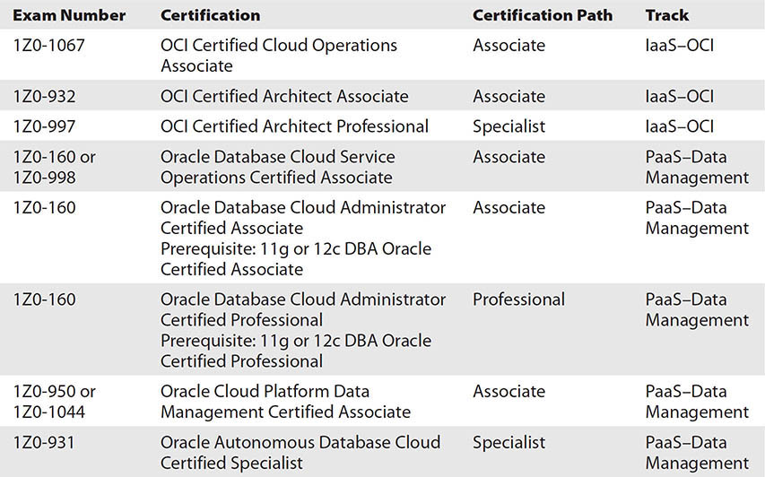

This book is written as a reference book, not just a study guide for a specific exam. This book completely covers the content in the associate exams and mostly covers the content in the professional and specialist exams. An exam object list is available with each exam on the Oracle website, and this list represents the current set to be tested for each certification exam. The object map that follows lists the chapters in this book and maps these to the exam objectives tested in the OCI Certified Architect Associate exam at the time of this writing.

### Exam 1Z0-1072

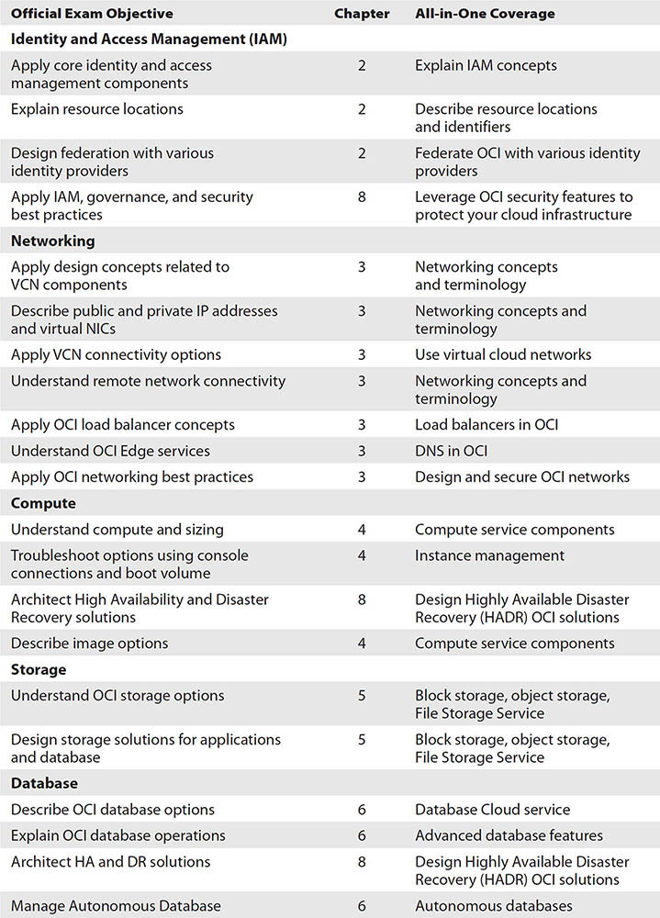

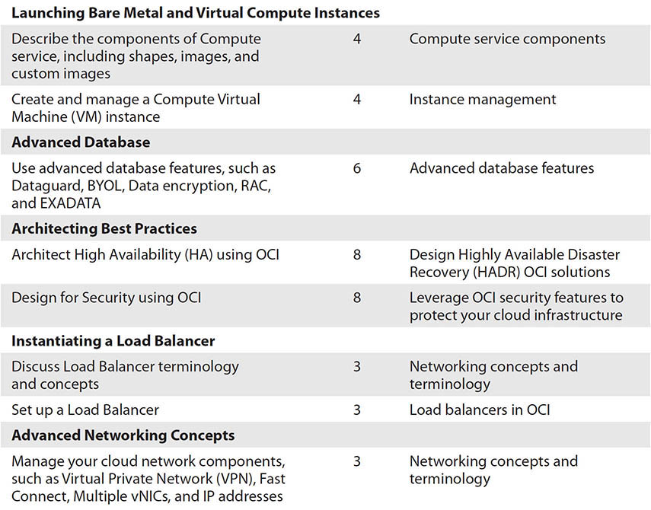

Many of these topics are tested in other exams listed in the previous table and have been included to provide a complete set of foundational information. To derive the most value from this book, I recommend choosing an exam you wish to attempt and cross-referencing the exam objectives from the Oracle certification website with the objectives listed in the table of contents to identify overlap and any exceptions.

One of the first exercises in this book involves signing up for an Oracle Cloud account. Oracle has blazed the trail here again by providing a Free Tier account that never expires. Other Cloud vendors may follow suit in due course. Study the material and experiment with your cloud tenancy as you work through the exercises and sample questions and become more familiar with the Oracle environment. You will realize that there is one golden rule: When in doubt, try it out.